**Step 1:** **Candidate will arrive at the ‘Submit I-9’ activity within Onboarding. Click on the I-9 Service Center link. Utilize the I-9 instructions as necessary.**

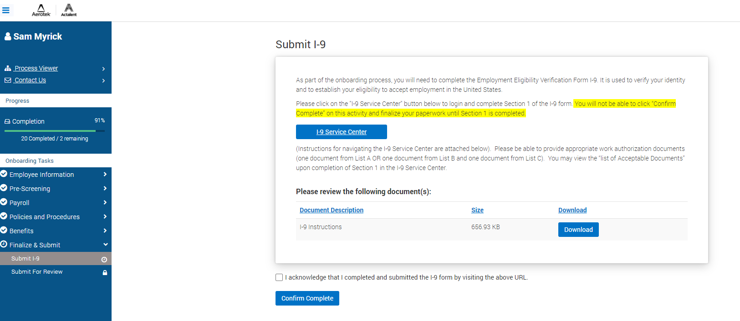

**Step 2: Complete Section 1 of the form**

• Click the Spanish/Español link to change the form instructions to Spanish

• Click the blue **Continue** button to begin completing Section 1

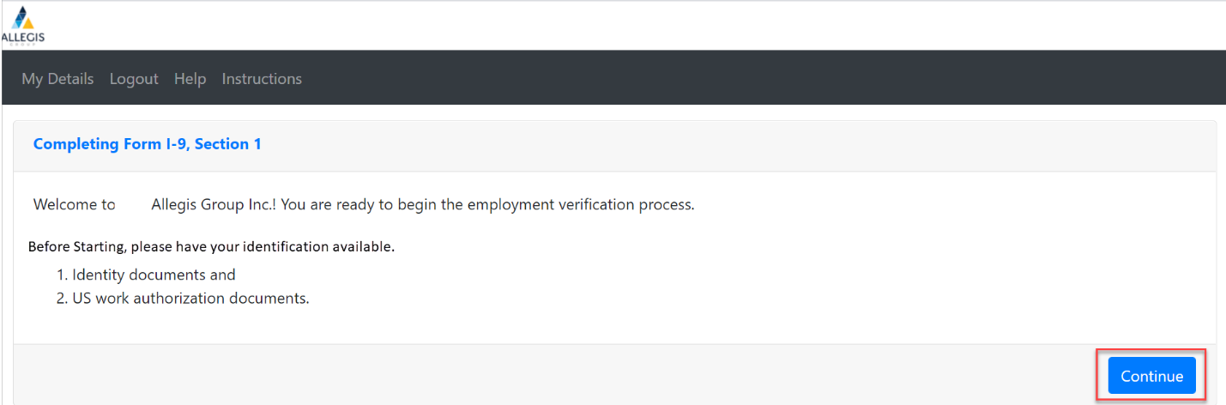

• All fields that need to be completed will be presented at the top of the page.

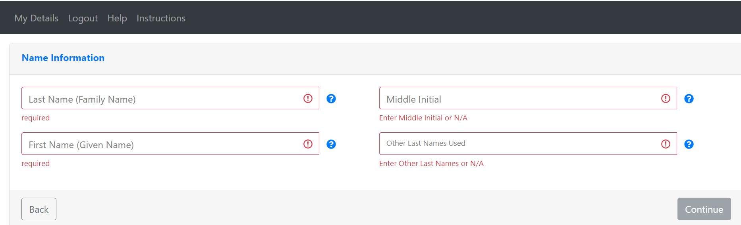

• Enter your full name including middle initial and any Other Last Names Used, if applicable.

• A green check mark will indicate when each field is complete. The Continue button will turn blue, indicating it is possible to move forward once all fields are complete. Click **Continue**.

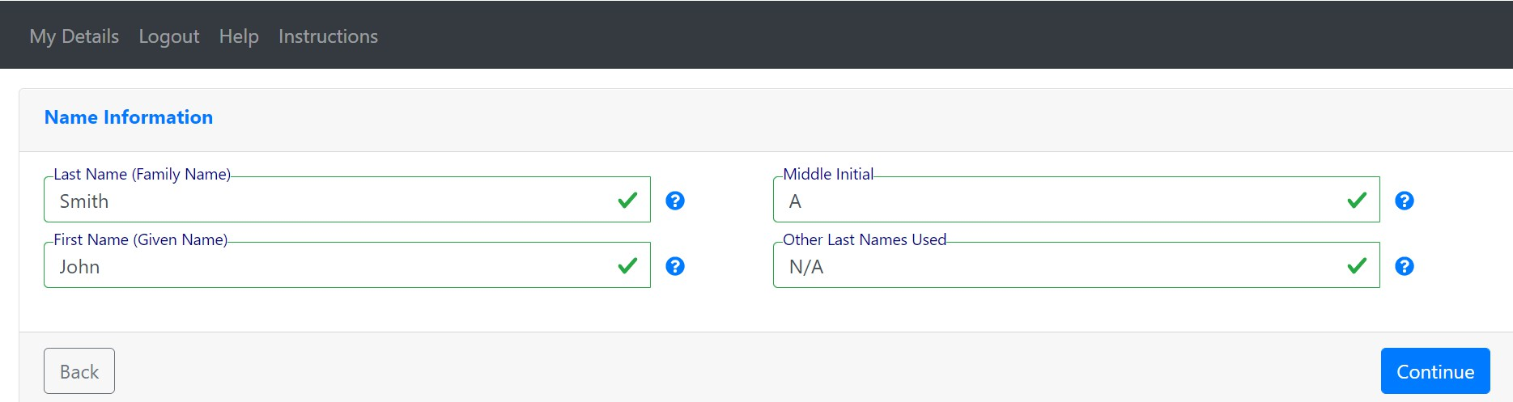

• Enter your current address, including street name and number **(PO Boxes are not acceptable in**

**Section 1)**. Click **Continue**.

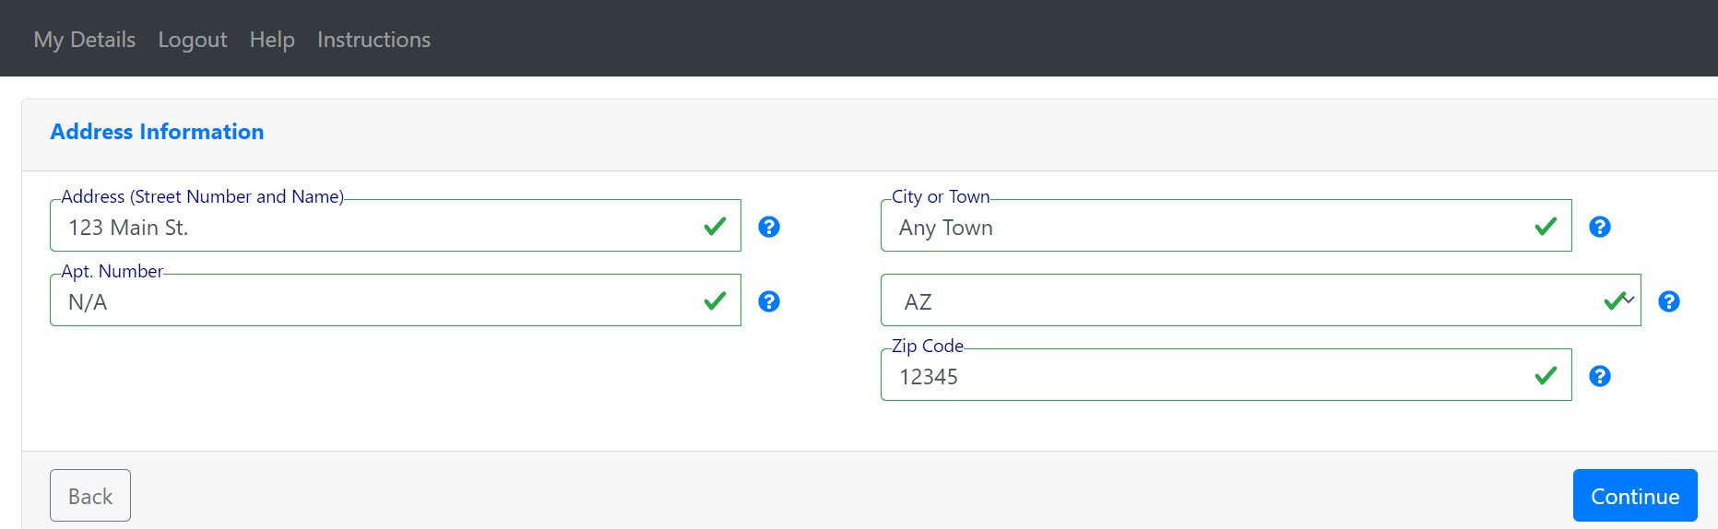

• Enter your Personal Information. We are an E-Verify employer therefore your **Social Security**

**Number is required**.

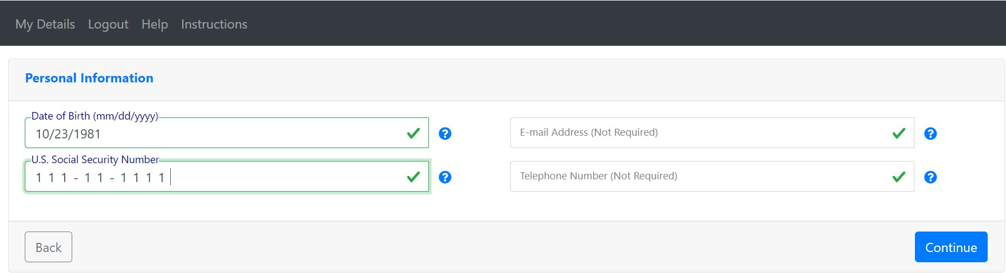

• Select your Citizenship Status and provide any additional information if indicated.

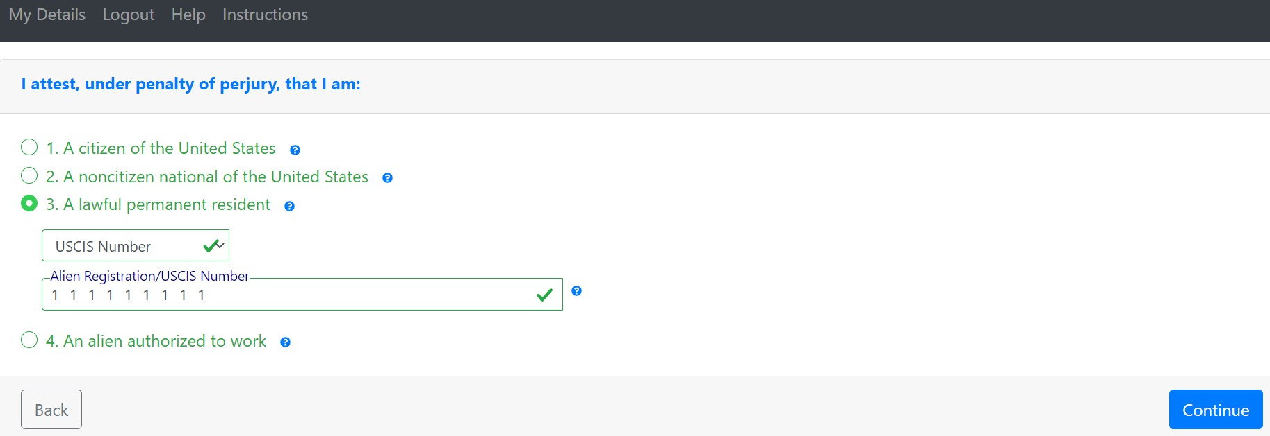

• Select if a Preparer or Translator was used to assist you in completing Section 1. Click **Continue**.

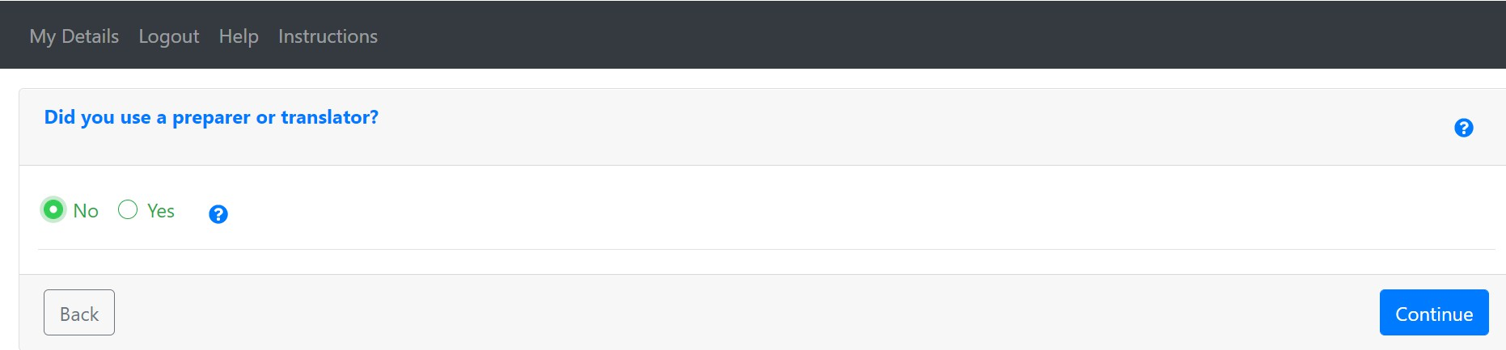

• Digitally sign your form by checking the box and typing your name exactly as entered in Section

1, including middle initial (if added), and click **Sign and Continue.**

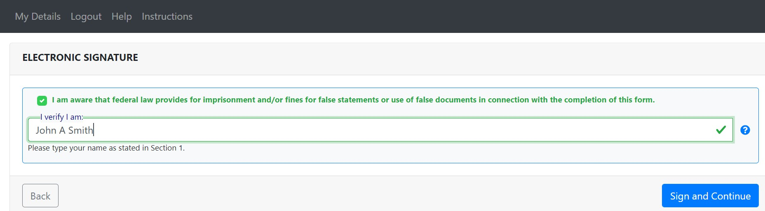

**Step 3: Upload Documents**

You have the option to upload copies of the documentation you will provide to the Employer Representative or Remote Agent for Section 2. You can take a photo or select an image from your camera roll on your mobile device or upload an image from your computer. If you are unable to add documents, click Continue to complete the form. You will have the ability to provide your documents to your Employer Representative when you bring the original documentation in for review.

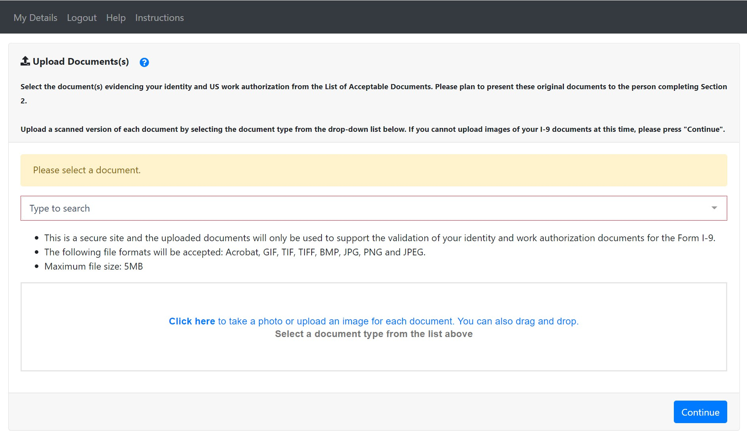

• A preview image will show next to the document type once uploaded. Instructions will appear if additional documents are required. Once your documentation is added, click **Continue** to finish.

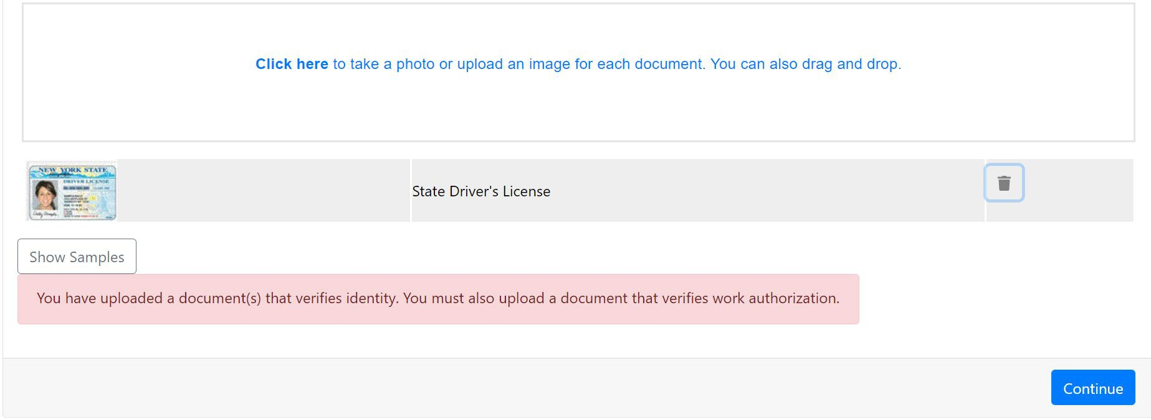

You are now finished with Section 1 of the I-9 form. You will be presented with a Digital Receipt which you can choose to print or email to yourself (optional).

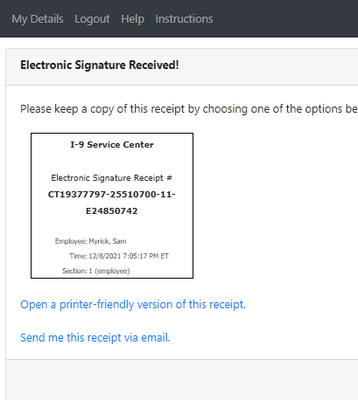

• Click the button to log out of the I-9 Service Center and return to your onboarding paperwork to finish the remaining forms.

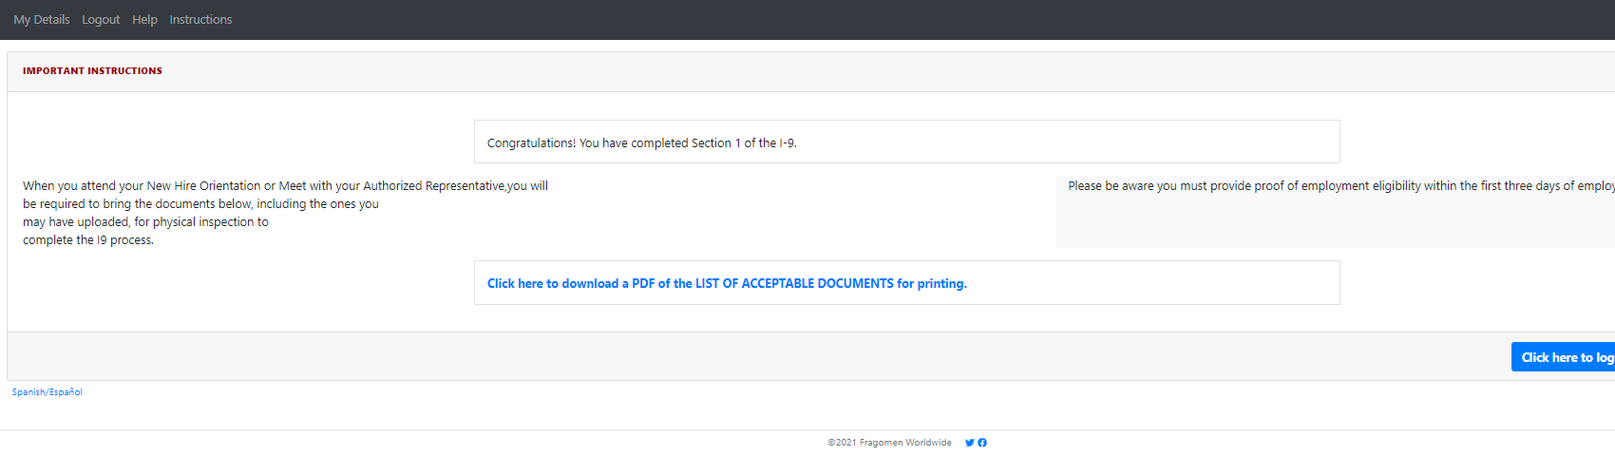

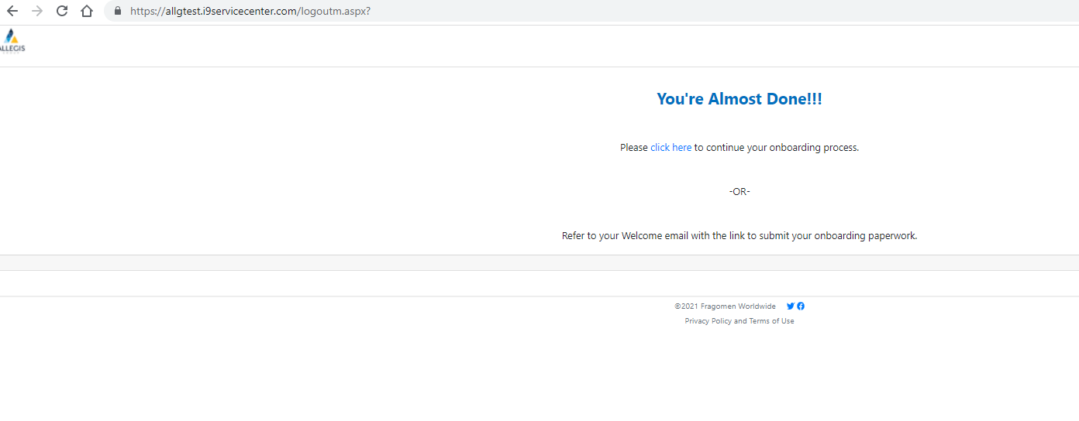

* Click on the ‘Click Here’ link. You will be brought back to your Onboarding Paperwork:

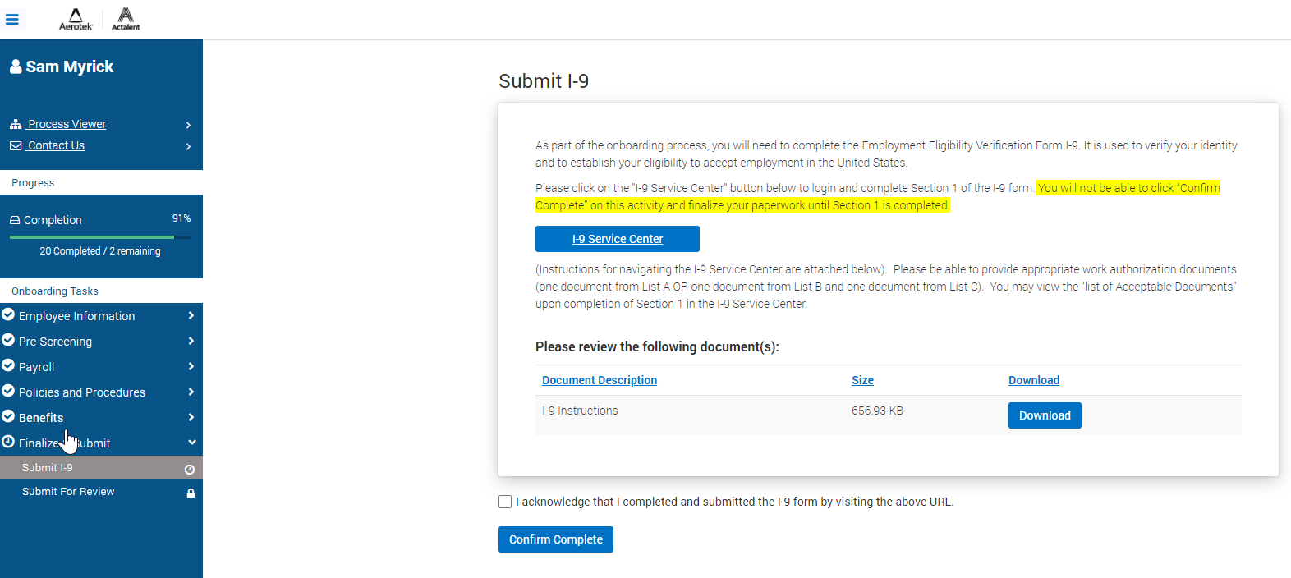

* Click on the Declaration box and clicked on Confirm Complete.

**PLEASE REMEMBER TO BRING THE ORIGINAL DOCUMENTATION YOU UPLOADED TO YOUR EMPLOYER OR DESIGNATED AGENT FOR SECTION 2 COMPLETION.**